**Batch: B2 Roll No.: 1611099**

**Experiment / assignment / tutorial No. 3**

**Grade: AA / AB / BB / BC / CC / CD /DD**

**Signature of the Staff In-charge with date**

|  |
| --- |
| **Batch: B2 Roll No.: 1611099 Experiment / Assignment / Tutorial No.: 3** |

|  |
| --- |
| **Title: Introduction to advanced shell programming.** |

**Objective:**

1. To understand and execute interactive shell command viz. sed, awk ,wget ,curl etc.
2. To execute Shell script on basis of interactive shell commands.

**____________________________________________________________________________**

**Expected Outcome of Experiment:**

1. Implementation of different scripting languages.

**___________________________________________________________________________**

**Books/ Journals/ Websites referred:**

1. *Linux Lab - Open source Technology : Ambavade –Dreamtech*
2. *Linux Shell scripting Cookbook: SarathLakshman PACKT 3.*
3. <http://www.theunixschool.com/p/awk-sed.html>
4. <http://www.thegeekstuff.com/2012/07/wget-curl/>
5. *www.geeksforgeeks.org/*

**____________________________________________________________________________**

**Pre Lab/ Prior Concepts:**

UNIX Operating System, Shell Basic Commands, Web Technologies.

**New Concepts to be learned:**  Filtering text processing, Hyperlink usage in shell scripting

**Introduction:**

A shell script is a computer program designed to be run by the Unix shell, a command-line interpreter.[1] The various dialects of shell scripts are considered to be scripting languages. Typical operations performed by shell scripts include file manipulation, program execution, and printing text. A script which sets up the environment, runs the program, and does any necessary cleanup, logging, etc. is called a wrapper.

The term is also used more generally to mean the automated mode of running an operating system shell; in specific operating systems they are called other things such as batch files (MSDos-Win95 stream, OS/2), command procedures (VMS), and shell scripts (Windows NT stream and third-party derivatives like 4NT—article is at cmd.exe), and mainframe operating systems are associated with a number of terms.

**Implementation details:**

**1. Max / Min of 2 numbers**

echo "Enter First Number"

read a

echo "Enter Second Number"

read b

if [ $a -gt $b ]

then

echo "$a is Max and $b is Min"

else

echo "$b is Max and $a is Min"

fi

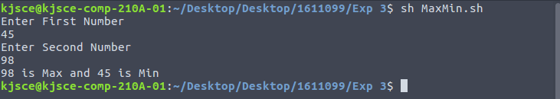

**2. Max / Min of 3 numbers using command line arguments**

if [ $1 -gt $2 -a $1 -gt $3 ]

then

if [ $2 -gt $3 ]

then

echo "$1 is Max"

echo "$3 is Min"

else

echo "$1 is Max"

echo "$2 is Min"

fi

elif [ $2 -gt $1 -a $2 -gt $3 ]

then

if [ $1 -gt $3 ]

then

echo "$2 is Max"

echo "$3 is Min"

else

echo "$2 is Max"

echo "$1 is Min"

fi

else

if [ $1 -gt $2 ]

then

echo "$3 is Max"

echo "$2 is Min"

else

echo "$3 is Max"

echo "$1 is Min"

fi

fi



**3.** **Max / Min of n numbers**

echo "Enter the Total numbers :"

read n

echo "Enter numbers :"

i=0

while [ $i -lt $n ]

do

read arr[$i]

i=$((i+1))

done

i=1

max=${arr[0]}

min=${arr[0]}

while [ $i -lt $n ]

do

if [ ${arr[$i]} -gt $max ]

then

max=${arr[$i]}

elif [ ${arr[$i]} -lt $min ]

then

min=${arr[$i]}

fi

i=$((i+1))

done

echo "$max is Maximum"

echo "$min is Minimum"

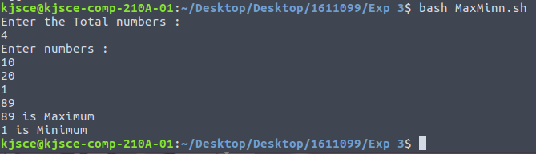

**4. Greeting a user differently depending on time of the day**

echo "Enter Hour"

read h

if [ $h -lt 12 ]

then

echo "Good Morning User"

elif [ $h -lt 18 ]

then

echo "Good Afternoon User"

elif [ $h -lt 24 ]

then

echo "Good Evening User"

elif [ $h -eq 24 ]

then

echo "Good Morning User"

fi

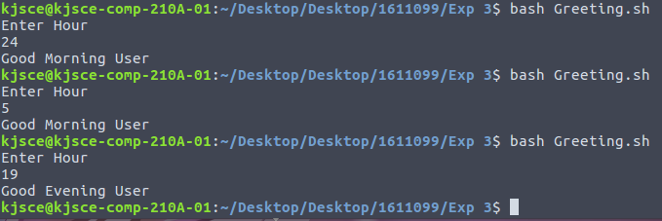

**5.** **Birthday Reminder example**

**6.** **Use of sed with examples (options)**

Input file:

unix is great os. unix is opensource. unix is free os.

learn operating system.

unix linux which one you choose.

unix is easy to learn.unix is a multiuser os.Learn unix .unix is a powerful.

**sed 's/unix/window/g' sed.txt**

**echo ""**

**sed '3 s/unix/window/' sed.txt**

**echo " "**

**sed '2,$ s/unix/window/' sed.txt**

**echo " "**

**sed '$d' sed.txt**

**echo " "**

**sed '/unix/d' sed.txt**

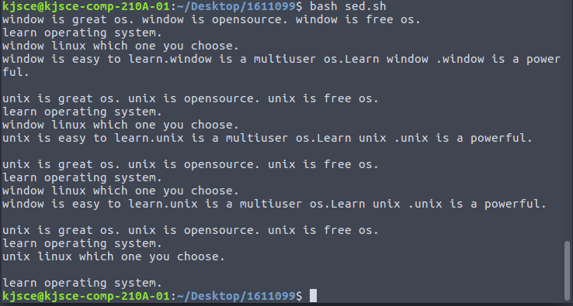

**7.** **Use of awk with examples (options)**

Input file:

ajay manager account 45000

sunil clerk account 25000

varun manager sales 50000

amit manager account 47000

tarun peon sales 15000

deepak clerk sales 23000

sunil peon sales 13000

satvik director purchase 80000

**awk '{print}' awk.txt**

**echo**

**awk '/clerk/ {print}' awk.txt**

**echo**

**awk '{print NR,$0}' awk.txt**

**echo**

**awk '{print $1,$4}' awk.txt**

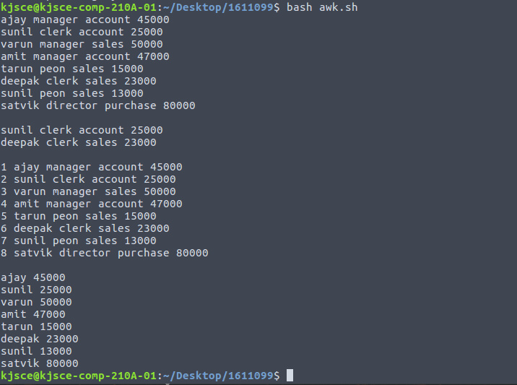

**8.** **Use of Wget with examples**

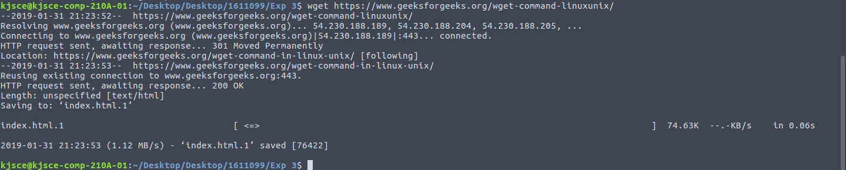

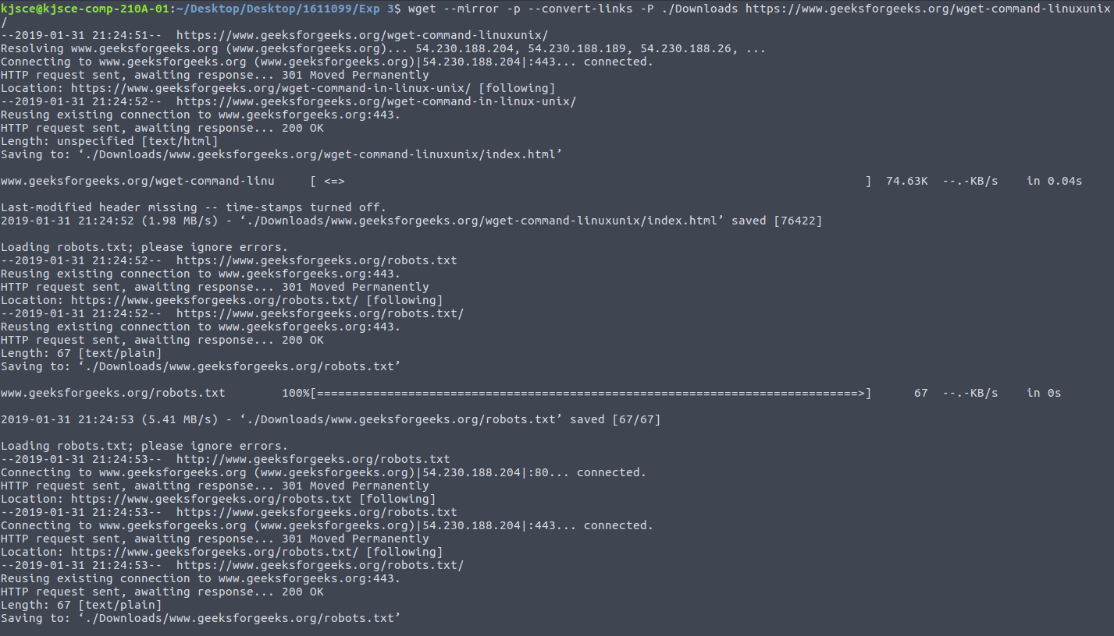

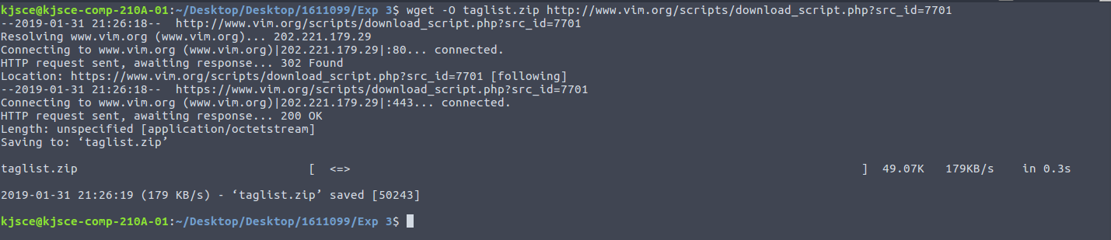



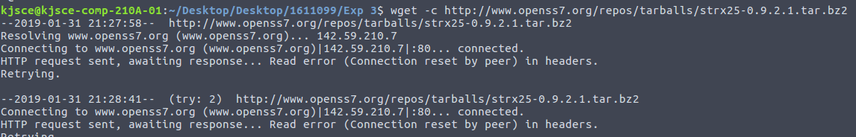

**9.** **Use of CURL with examples**

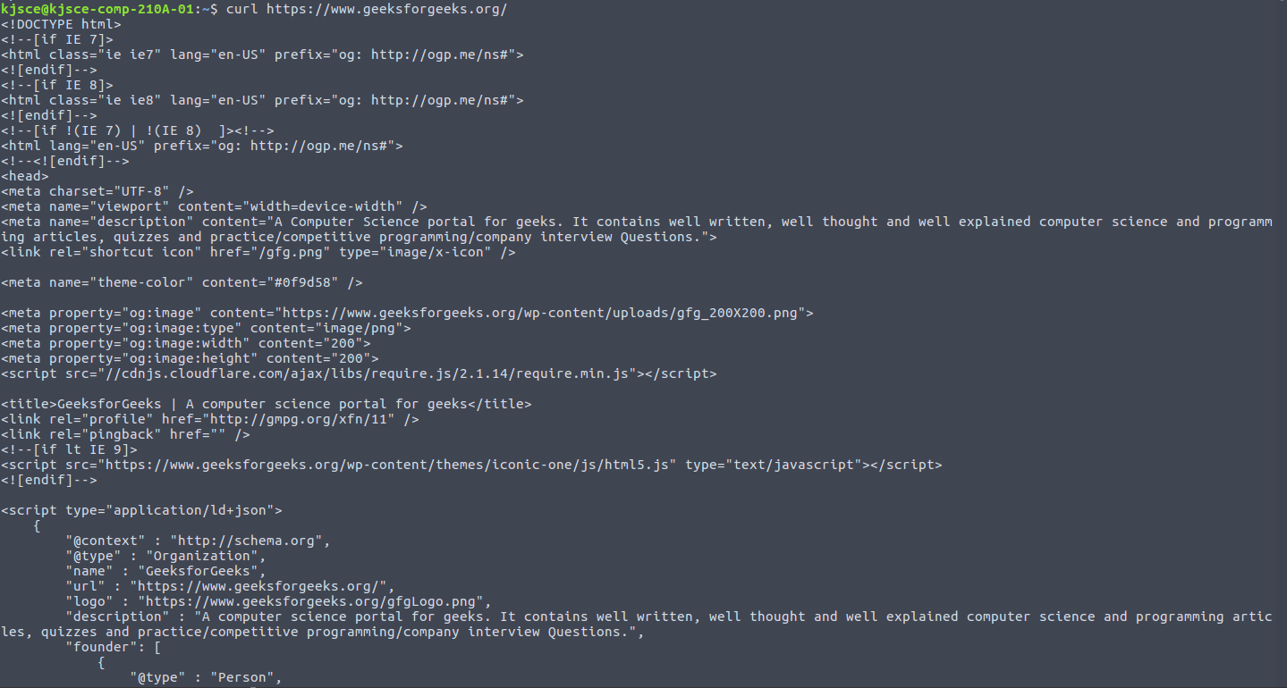

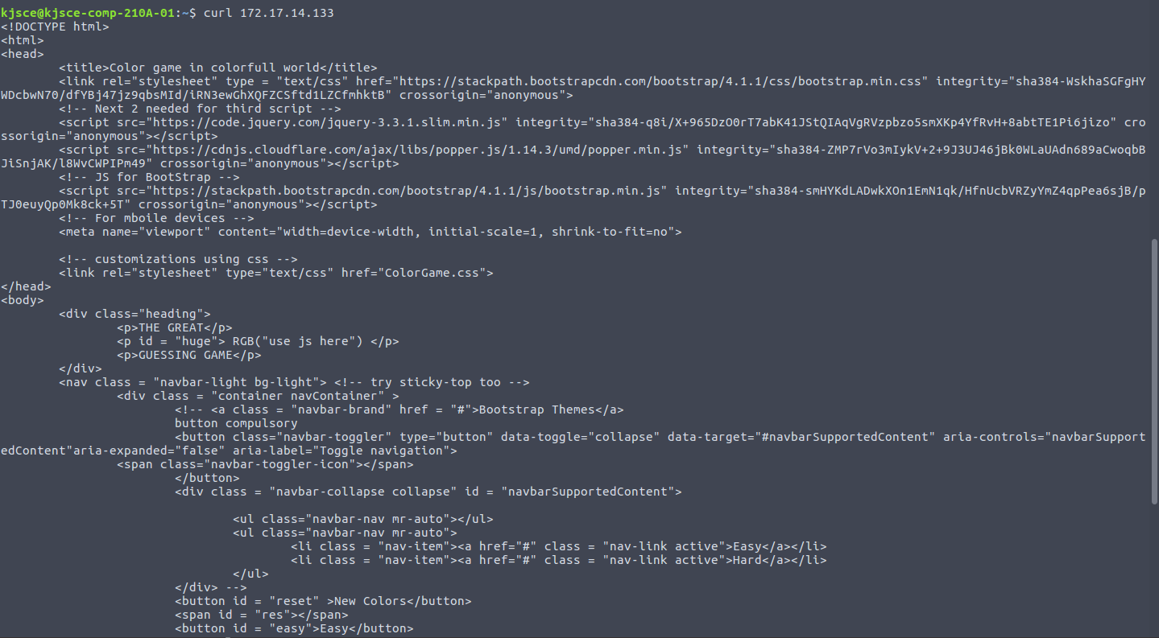

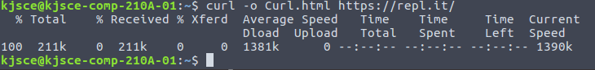

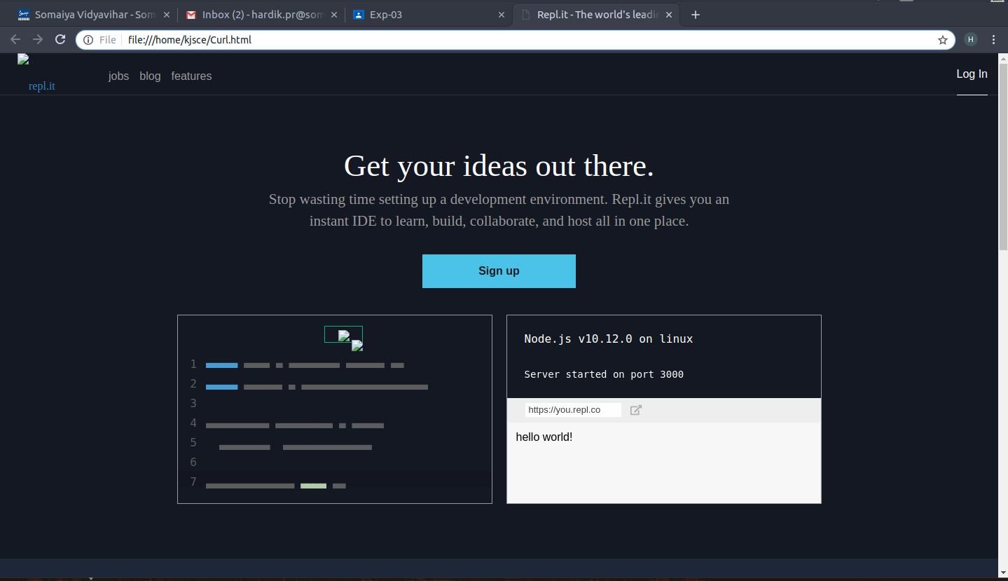

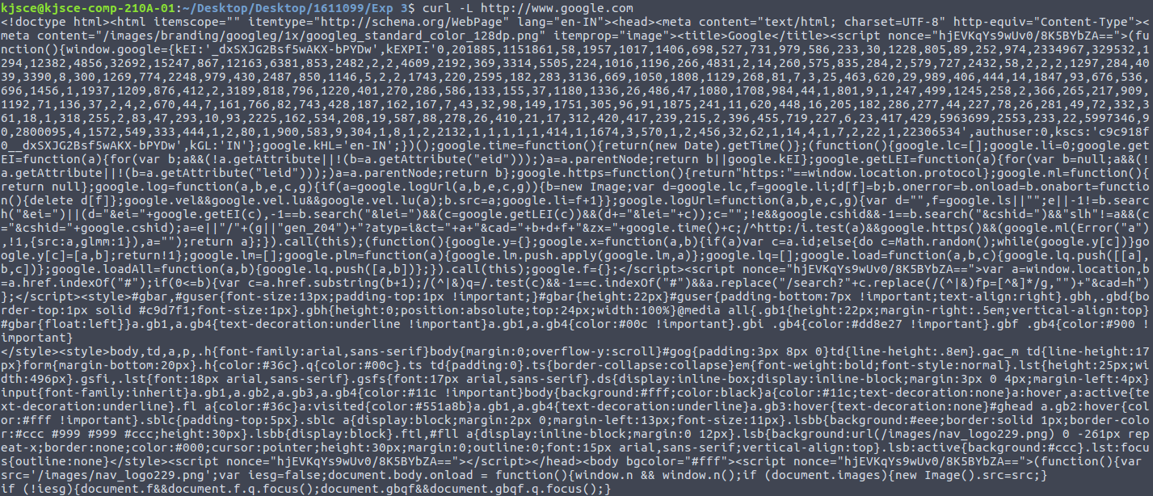

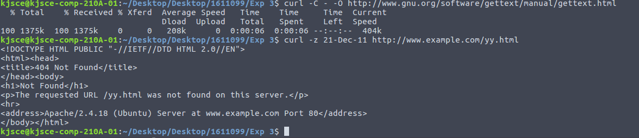

**Conclusion:**